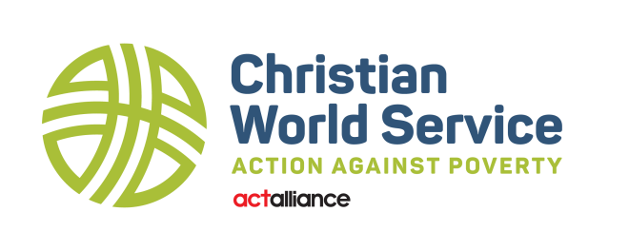

Report to the 66th Session of the General Synod/te Hīnota Whānui (GSTHW) 2024
Kia ora koutou, and very warm Christian greetings to you Te Hāhi Mihinare ki Aotearoa ki Niu Tireni, ki Nga Moutere o te Moana Nui a Kiwa, the Anglican Church in Aotearoa, New Zealand and Polynesia
Christian World Service (CWS) has continued to receive very much appreciated support from the Anglican family of congregations. Additionally, we have recently appreciated support from the Church centre as we have embarked on significant restructuring to ensure the organisation evolves in response to the changing world around us. Thank you for our partnership in making God’s love more visible in the world.
The generosity of people responding to the high levels of humanitarian or emergency need in situations of war, conflict and natural disaster around the world is a current feature of our ministry. Additionally, we continue to place much an emphasis on addressing issues associated with injustice and poverty. Regrettably, this work is continues as our prime focus, due to the impact of Covid-19. The United Nations claims the pandemic has reversed decades of positive progress in the areas of poverty, healthcare, and education amongst those who, like us, are made in the image of God. On your behalf, CWS is called to see the globe transformed to a place where people live free from poverty in all its forms and are safe from harm.
Funding our Partners
From the generous donations of our supporters, CWS makes grants to our partners around the world for their local development programmes and their efforts towards humanitarian aid. Many of our partners are experiencing new challenges as they help people face the fresh wave of the rising cost of living brought about through the pandemic, the invasion of Ukraine, and the effects of climate change. Since our last report, grants have assisted people in 23 countries including the Occupied Palestinian Territory. Some of the grants included:
- Emergency responses in Bangladesh for Rohingya refugees
- Emergency responses in Hungary, Poland, Romania and Ukraine to assist those affected by war.
- Relief for people in Afghanistan and those who fled to Pakistan
- fleeing famine in East Africa
- Support for cyclone survivors in Vanuatu
- For flood victims in Pakistan
- Earthquake survivors in Türkiye and Syria
- People in Haiti after the 2021 earthquake
- Families and communities impacted by the Hunga Tonga-Hunga Ha’apai eruption and tsunami, and
- Many of our long-term development partners responding to the imp[act of Covid-19 in communities.
Generous donations, totalling more than $500,000.00 have been distributed via our global partner, the ACT Alliance (Action by Churches Together). This has provided much needed aid and support following crisis and disaster. We were grateful to receive a $150,000.00 grant from the Ministry of Foreign Affairs and Trade to assist Ukrainian refugees, particularly in Poland. Our ACT Alliance partner the Lutheran World Federation has supported refugees with emergency cash grants and assistance, child-friendly spaces, women’s programmes, psychosocial care, and disability support.
More latterly, the war in Gaza has also been a focus for our attention. Here, we have raised funds to support our partner, the Middle East Council of Churches Department of Service to Palestinian Refugees (DSPR) who are currently working amongst some of the world’s most vulnerable. In Rafah, a Southern town of Gaza housing 200,000 persons, the population is now over 1.2 million. DSPR has a medical clinic where 30 staff are working round the clock. They offer dental care, medicine, and health supplies to over 400 persons each day. Additionally, they are providing small cash payments to families for food and water, delivering workshops on serious hygiene-related problems, and offering psychosocial interventions for children aimed at offering a tiny a measure of trauma relief through games, activities, and clowns.
Discerning a Fresh Direction for our Future
The CWS Board has initiated a refresh of its strategic direction and is currently consulting with core partners with an aim of uniting and energising us towards the founding goals of the organisation - including poverty alleviation and working for justice amidst all God’s creation, and especially those who are most disadvantaged. While we are early in the process of drafting a new ‘Statement of Intent’ some of our identified goals include:
- Development of new partners within the Pacific - increasing support for our closest neighbours.
- A specific focus on climate justice - the primary concern of Pacific.
- Development of leadership amongst a younger generation of Christocentric social activists.
- Creating genuine partnerships with Māori and Pacific churches within Aotearoa New Zealand.
Sharing the Vision
CWS continues to re-establish engagement with church communities following the impact of Covid-19. Sharing some of the inspiring stories that tell of the work, service, and ministry undertaken by our partners is crucial To this end, we seek local CWS champions who will promote our work across congregations. Alternatively, if you would like someone from our staff team to come and share at your church. Please let us know.
In conclusion, to achieve our mission of creating a world free from poverty, engaging in global emergency relief, and working for justice, we value your ongoing assistance though:
- Congregational prayer
- Profile in worship services
- Financial support of our partners
- Advocacy for a fairer world
- Actively working for climate justice, and
- Offering your time as a CWS volunteer
For more information about the work of Christian World Service, please go to our website @ www.cws.org.nz or facebook @ https://www.facebook.com/christianworldservice
Ngā manaakitanga
Tim Pratt PhD MBA (Dist) DipTheol
National Director

Feb 25 2024

